**MODUL 4: TALKING ABOUT FAMILIES AND FRIENDS**

**MATERI:**

Describing Appearance and Personality

Pelajari contoh di bawah ini tentang deskripsi seseorang:

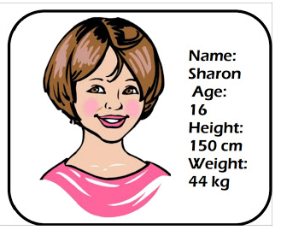

*Sharon is a high school student. She is young. She is short and slim. She has short, curly, brown hair and big brown eyes.*

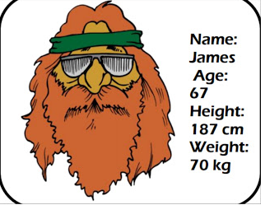

James is a musician in a rock group. He is tall and he is slim. He has got long, straight red hair. He is wearing glasses. He is old.

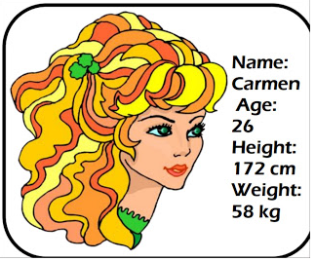

Carmen is a pretty woman. She is young. She is of medium height and she is slim. She has long, wavy fair hair and green eyes.

Untuk mendeskripsikan orang, gunakan kalimat **nominal** dengan format: **S + tobe + Adj/Noun/Adverb**

***Identification*** : Who is she? This is …….( Tina, my friend, my sister etc). This is my friend, Tina.

***Appearance (Adj)*** : She/he is……(skinny, old, tall, fat). She is beautiful, skinny, and tall.

***Appearance possessive (has+ adj)*** : She/he has …….(long hair, big round eyes, etc). She has big round eyes, long hair, and a sharp nose.

***Personality*** : She/he is a ……(smart, kind, lovely) woman/mam/girl/boy. She is a smart woman. She is kind and lovely.

Untuk membicarakan keluarga/family silahkan menggunakan ungakapan sebagai berikut:

I have **two/one/three** brothers and **one/two/three** sisters. I am the only child in my family.

I am the **first/second/third/fourth/fifth** child in my family.

I have a **small/big** family.

My parents are …..(name)

My father is a…..and my mother is a….(profession)

Pelajari kosakata berikut untuk membicarakan keluarga dan teman

**Kakek dan Nenek** : grandparents

**Ayah**: father

**Ibu**: mother

**Bibi**: aunty

**Paman**: uncle

**Kakak laki2**: older brother

**Adik laki2**: younger brother

**Kaka perempuan**: older sister

**Adik perempuan**: younger sister

**Sepupu** : cousin

**Keponakan perempuan**: niece

**Keponakan laki2** : nephew

**Mertua laki2**: father in law

**Mertua perempuan** : mother in law

**Kaka ipar** : brother in law

**Adik ipar**: sister in law

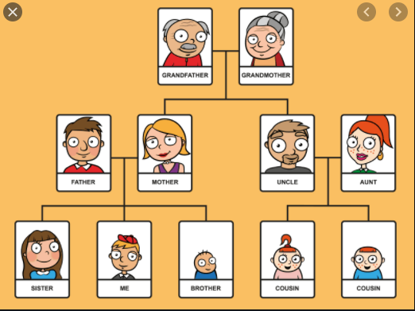

**Kosakata untuk membicarakan penampilan**

Face= wajah

Slanted eyes= sipit

Pointed nose = mancung

Flat nose = pesek

Ears= telinga

Lips= bibir

Hair=rambut

Straight hair = rambut lurus

Wavy hair = rambut ikal/ bergelombang

Curly hair = rambut keriting

Bald = botak

Blonde hair = rambut pirang

Black hair = rambut hitam

Red hair = rambut pirang (kemerah-merahan)

Grey hair= uban

Pigtail = rambut dikuncir

Sideburns = cambang

Thin face = wajah kurus

Round face = wajah bulat

Chubby face = wajah gemuk/ tembem

Wrinkles = keriput

Freckles = bintik-bintik di wajah (matahari)

Beard and moustache = jenggot dan kumis

**Height and Build (Tinggi badan dan perawakan)**

Slim = langsing

Obese = obesitas

Fat = gendut

Overweight = gendut

Stocky = pendek gemuk

Well-built = tegap, berotot

Muscular = berotot

Well-built= kekar

Thin = kurus

Skinny = kurus

Tall = tinggi

Short = pendek

Medium height = tingginya sedang-sedang saja

**Complexion (warna kulit)**

Fair skin = berkulit putih

Yellow skin = berkulit kuning (warna kulit orang asia)

Dark/ black skin = berkulit hitam

Tanned skin = agak gelap kemerahan

**Age (usia)**

Baby= bayi

Toddler= Balita

Child (anak), kata jamaknya children yang berarti anak-anak

Teenager= remaja

Young Adult = dua puluhan

Adult= dewasa

Middle-aged= paruh baya

Elderly= orang tua

**General Appearance (Penampilan umum)**

Elegant = elok, elegan

Tidy= berpakaian rapi

Untidy = tidak rapi

Good looking = menarik, cantik, tampan

Unattractive = tidak menarik

Beautiful = cantik

Handsome = tampan

Attractive = menarik (penampilan)

Charming = menarik (penampilan)

Ugly = jelek

Gorgeous= indah

Messy= berantakan/tidak rapi

**Kosakata Describing personality:**

Berikut adalah kosakata untuk menjelaskan sifat seseorang

Honest= Jujur

Ambitious= Ambisius

Arrogant= Sombong

Diligent= Rajin

Lazy= Malas

Persistent= Gigih

Tough= Tabah

Mischievous= Jahil

Bad-tempered= Pemarah

Truthful/Sincere= Tulus

Sly= Licik

Naughty= Nakal

Grudging= Pendendam

Forgiving= Pemaaf

Forgetful= Pelupa

Humble  = Rendah Hati

Reckless= ceroboh

Ignorant= Cuek

Cold-Hearted= Berhati Dingin

Greedy= Rakus

Cheerful= Periang

Calm= Tenang

Bossy= Suka Memerintah

Shy= Pemalu

Confidence= Percaya Diri

Naughty= Nakal

Pious= Alim

Easy To Get Going= Mudah Bergaul

Graceful= Lemah Gemulai

Polite= Sopan

Liar= Pembohong

Perhatikan gambar berikut;

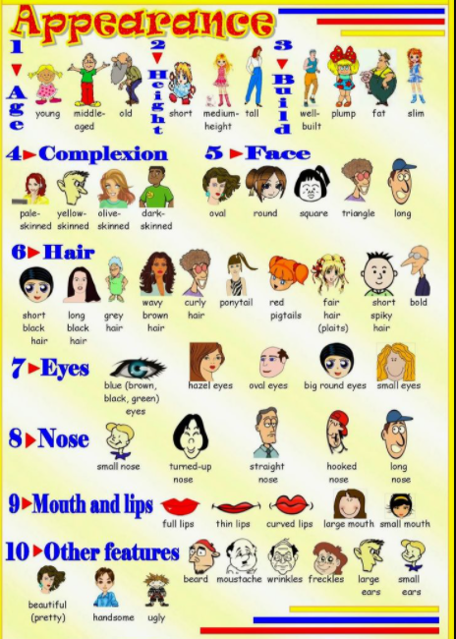

Pelajari link berikut untuk lebih lanjut:

1. Describing people youtube link : <https://www.youtube.com/watch?v=U4PmVQSCLiA>
2. Talking about family youtube link: <https://www.youtube.com/watch?v=NCuuym7xiRo>

TUGAS:

1. Silahkan pilih sesorang yang kalian kenal (keluarga atau teman) upload foto dan deskripsi teman tersebut pada padlet link: ada di ELA

Perhatikan contoh berikut:

|  |  |
| --- | --- |
|  | *I have a lot of friends in my school, but Lisa is my best friend since junior high school. We don’t study in the same class, but we meet at school every day during b breaks and after school. I first met her at junior high school orientation and we’ve been friends ever since.*  *Lisa is good-looking. She’s not too tall, with fair skin and straight brown hair that she often puts in a ponytail. At school, she wears the uniform. Other than that, she likes to wear jeans, casual t-shirts and sneakers. Her favourite t-shirts are those in bright colors like pink, light green and orange. She is always cheerful. She is also very friendly and likes to make friends with anyone. Like many other girls, she is also talkative. She likes to share her thoughts and feelings to her friends. I think that’s why many friends enjoy her company. However, she can be a bit childish sometimes. For example, when she doesn’t get what she wants, she acts like a child and stamps her feet.* |

1. Kerjakan kuis sesuai petunjuk ELA

*I have a lot of friends in my school, but Lisa is my best friend since junior high school. We don’t study in the same class, but we meet at school every day during b breaks and after school. I first met her at junior high school orientation and we’ve been friends ever since.*

*Lisa is good-looking. She’s not too tall, with fair skin and straight brown hair that she often puts in a ponytail. At school, she wears the uniform. Other than that, she likes to wear jeans, casual t-shirts and sneakers. Her favourite t-shirts are those in bright colors like pink, light green and orange. She is always cheerful. She is also very friendly and likes to make friends with anyone. Like many other girls, she is also talkative. She likes to share her thoughts and feelings to her friends. I think that’s why many friends enjoy her company. However, she can be a bit childish sometimes. For example, when she doesn’t get what she wants, she acts like a child and stamps her feet.*

I have a best friends in my life. her name is Ziyan, I've known her since high school. We do anything together, even when we study in the same department and class. We also rent the same house. He is very kind and his smile is so sweet that many want to be friends with him. That's why I'm happy to be friends with him.

Ziyan is very beautiful with chubby cheeks and small teeth that looks very cute. Ziyan has black and straight hair but when she goes to school she wears a hijab because she is Muslim. Ziyan has dark brown eyes that are very beautiful when exposed to the sun. Her body is as tall as me with the same tan skin color as me. She likes to wear comfortable culottes with a blouse and headscarf that covers the hair on her head. Her favorite style is girly that's why she really likes shopping for clothes.